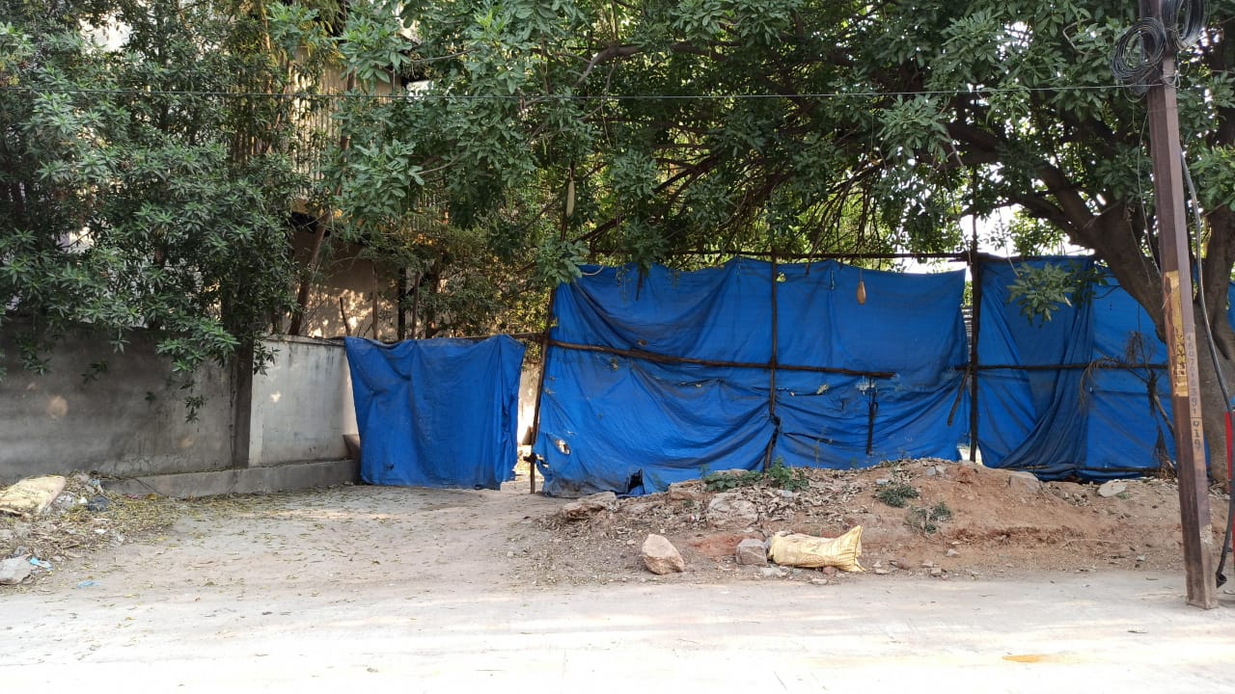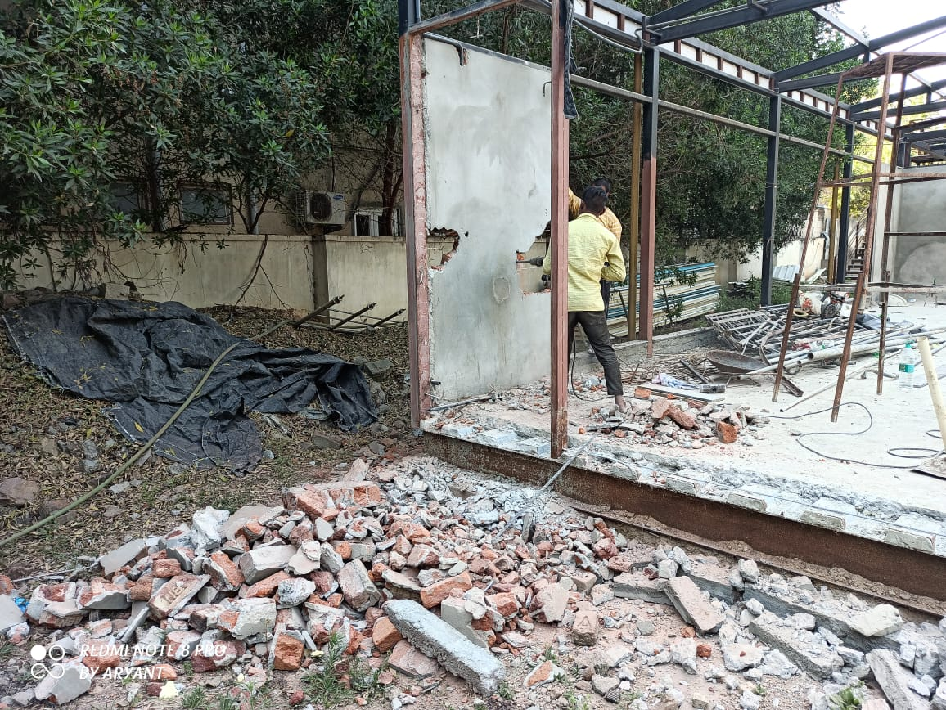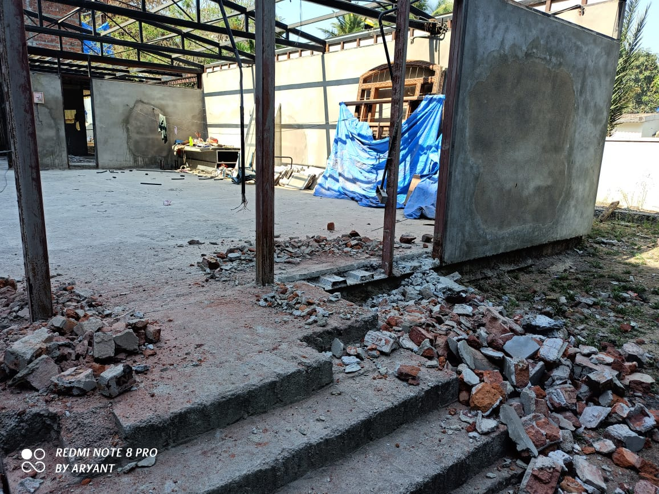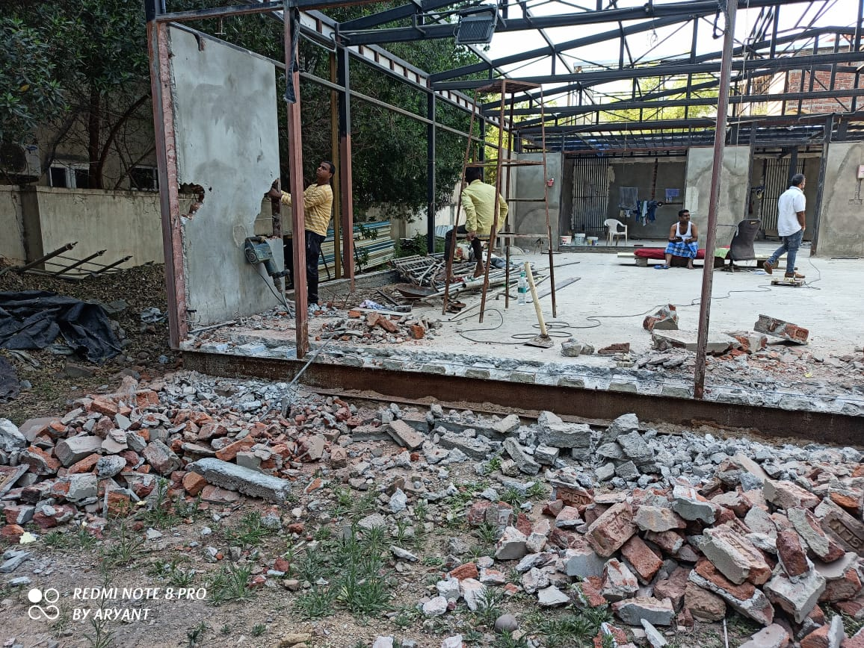

**Property Details**:

Area Name : Jubilee Hills

Road No : 46

Facing :

Dimensions :

Price : 2.10 L per Sq Yard, Negotiable

Other Remarks :

Location Pin : 17°25'50.6"N 78°23'49.4"E - Google Maps